**Form Function not opening:**

sAfter click on ICP icon under AP user responsibility it was throwing an Error. As Show below.

Switch to System Administrator responsibility and follow the below Navigation.

Application 🡪 Menu

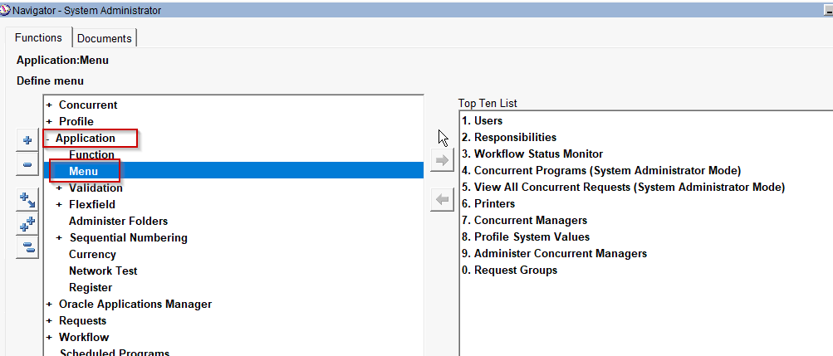

Press F11🡪 Enter User Menu Name As ‘**ESH AP User Menu**’ 🡪 Ctrl+F11

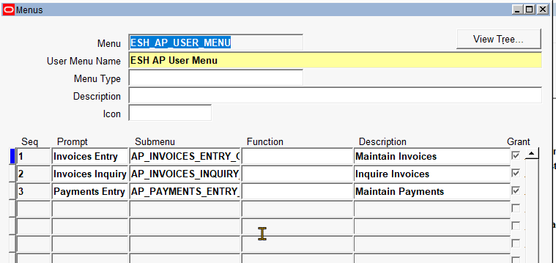

Enter 4 Seq and add function and Description as shown below.

|  |  |  |
| --- | --- | --- |
| SEQ | Function | Description |
| 4 | ESH AP Invoice Batch Approval History | ESH AP Invoice Batch Approval History |
| 5 | Invoice Certification Process | Invoice Certification Process |

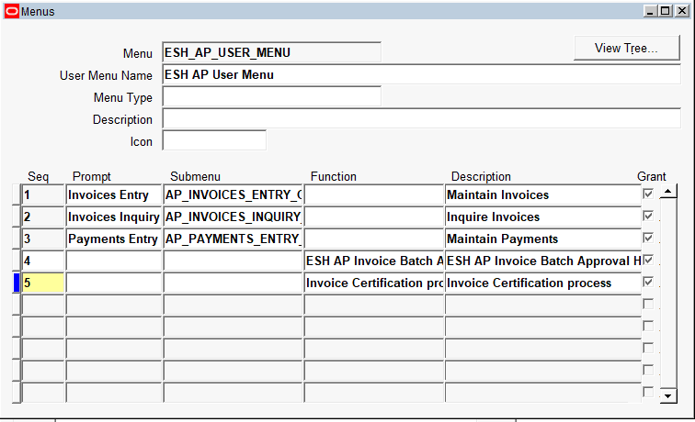

And click on save button. A popup was open and showed the request id.

**Recall Setup:**

Once the invoice is submitted for approval, user trying to recall the invoice. It was not opening. click on OK. Then the recall form should be open. It was not opening.

Then open the following profile from the system administrator responsibility.

Profile: ESH ICP Allow User to Recall the Invoice(s)

Set at user level to enable the profile to **Yes**.

Save the details and switch to AP user responsibility and open the invoice and click on ICP icon.

